Data Sheet
Product Information
Product Name | : | Recombinant Human Interferon-gamma (rhIFN-γ)
Synonyms | : | IFNG, IFG, Immune Interferon, type II interferon, T cell interferon, MAF
Description | : | Interferon gamma (IFNγ) is a dimerized soluble cytokine that is the only member of the type II class of interferons. IFNγ is critical for innate and adaptive immunity against viral, some bacterial and protozoal infections. IFNγ is an important activator of macrophages and inducer of Class II major histocompatibility complex (MHC) molecule expression. (Ref. From Wikipedia)
NCBI Accession No. |  | NM_000619.2
Amino acid sequence | : | MKYTSYILAFQLCIVLGSLGCYCQDPYVKEAENLKKYFNAGHSDVADNGT  LFLGILKNWKEESDRKIMQSQIVSFYFKLFKNFKDDQSIQKSVETIKEDM  NVKFFNSNKKKRDDFEKLTNYSVTDLNVQRKAIHELIQVMAELSPAAKTG  KRKRSQMLFRGRRASQ
Molecular Mass | : | 16.87 kDa (144 aa)
Protein Tags | : | No tagging
Source | : | E. coli.
Cat. No. | : | JW-H020-0010, JW-H020-0025, JW-H020-0050, JW-H020-0100, JW-H020-0250, JW-H020-0500, JW-H020-1000
Storage | : | Should be at ≤ -70 ℃ as undiluted aliquots of handy size. Avoid repeated freezing and thawing.
Cross Reactivity | : | Human, Mouse Rat, Monkey, Pig

Quality Control
Test items |  |  |  | Specifications
Appearance |  |  | : |  | Clear, colorless liquid
Purity |  |  | : |  | Greater than 98 % by RP-HPLC and SDS-PAGE
Specificity |  |  | : |  | Using Western blot, detection | 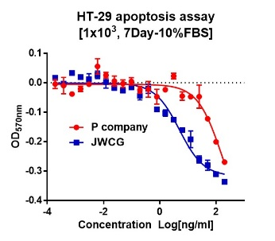
Concentration |  |  | : |  | 0.1 mg/㎖, Bradford method
Biological Activity |  |  | : |  | Determined by cytotoxicity of HT-29 indicator cells.  The ED50 is < 0.05 ng/ml, corresponding to a specific activity of > 2.0 × 10⁷ U/mg
Endotoxin |  |  | : |  | Less than 0.1 EU/㎍ as determined by the LAL method
Formulation |  |  | : |  | 20mM sodium phosphate, 5% glycerol (pH 7.4) without preservative or carrier proteins.
Stability |  |  | : |  | Stable for up to 12 months at -70 ℃. Stable for a month at 4 ℃.
Sterility |  |  | : |  | Sterilized through a 0.2 ㎛ membrane filter and packaged aseptically. Culture for 2 weeks, no growth

